**4. Architecture**

**4.1 Overview**

The architecture takes what was covered in the other sections and uses them as a guide to build out how our system shall work and operate

**4.2 Subsystem Model**

This shows the various logical systems that all communicate to make the system as a whole function.

4.2.1 Wildfire Management System

Four subsystems comprise this system (Wildfire Locator, User Locator, Wildfire Prediction, User Warning) that all work together to properly inform users of predicted wildfire behavior.

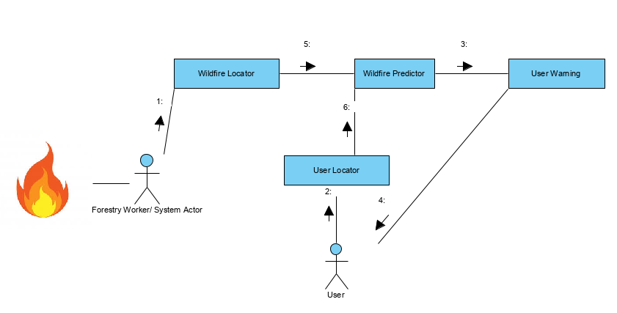

|  |  |
| --- | --- |
| Name | Wildfire Locator |
| Description | This subsystem is activated when a wildfire is identified by and reported by a user of the subsystem. |
| Meet FR | 1, 3, 6 |
| Meet NFRs | 1.1) System is available 24/7 for reporting.  1.3) Any issues involved with locating wildfires must be dealt with immediately.  3.2) System should be able to handle reporting multiple wildfires.  4.3) Wildfires must be verified by credible source or multiple users for accurate data collection. |
| Quality Scenarios | The user locates a wildfire, reports it to the system, and the system will register the fire. |

|  |  |
| --- | --- |
| Name | User Locator |
| Description | This subsystem is activated when a user identifies their location through the system |
| Meet FR | 1, 2, 4, 6 |
| Meet NFRs | 1.1) System is available 24/7 for reporting.  1.3) Any issues involved with locating users must be dealt with immediately.  2.1) System should be able to handle reporting multiple users.  4.1) Location data of users will be kept private.  4.3) User data will not be available for malicious use. |
| Quality Scenarios | The user sends their location data to the system and the system logs the user locations |

Wildfire Predictor Sequence Diagram

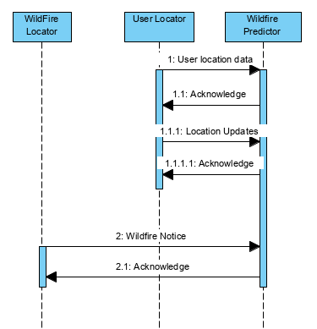

|  |  |
| --- | --- |
| Name | Wildfire Predictor |
| Description | This subsystem is activated when a wildfire is reported. Data is analyzed here to determine the wildfire prediction and appropriately notify any stakeholder. |
| Meet FR | 3, 4, 6 |
| Meet NFRs | 1.1) System is available 24/7 for reporting.  1.2) Any issues involved with analyzing wildfires must be dealt with immediately.  1.3) All analyzing issues will be fixed immediately  2.3) System will be able to handle all users.  3.1) System will allow all users to access data and will analyze any user updates to location data.  4.2) Data will not be maliciously manipulated to alter the analyzer.  5.4) All data will be logged within 30 seconds |
| Quality Scenarios | The user locates a wildfire, reports it to the system, and the system will register the fire. |

User Warning Sequence Diagram

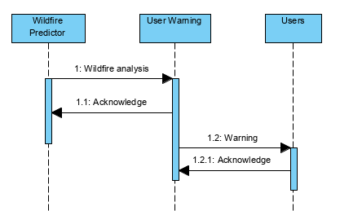

|  |  |
| --- | --- |
| Name | User Warning |
| Description | This subsystem is activated when the wildfire and user data is analyzed so that the system can make accurate warnings so that the users can take safety precautions from the wildfires. |
| Meet FR | 1, 2, 5, 6 |
| Meet NFRs | 1.1) System is available 24/7 for warnings.  1.2) Any issues involved with warning users must be dealt with immediately.  1.3) All warning issues will be fixed immediately  2.3) System will be able to handle all users.  3.1) System will allow all users to access data and will analyze any user updates to location data.  4.2) Data will not be maliciously manipulated to alter the warnings.  5.4) All data will be logged within 30 seconds |
| Quality Scenarios | The wildfire data and user data are analyzed to produce warnings for the appropriate users so that they can take precautions against wildfires |

**4.3 Target Environment**

**4.3.1 Deployment Diagram**

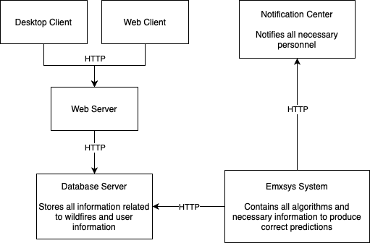

**4.3.2 Explanation of Components in Deployment Diagram**

|  |  |
| --- | --- |
| Name | Desktop Client & Web Client |
| Description | The outward facing system that allows users to interact with the Emxsys system. |
| Meet FR | 1, 2, 6 |
| Meet NFRs | 1.1) The system must be available 24/7 since it is an emergency platform.  1.2) Customer support must be available 24/7 since it is an emergency system and users might need support for an emergency at any time.  2.1) System should be able to handle thousands of users interacting with the system at once from different locations, but the likelihood of multiple catastrophic wildfires happening concurrently are low but not impossibly.  2.2) System should support the ability to add tutorials.  3.1) System should be able to handle collecting data on thousands of concurrent users without slowing down the system.  3.2) System should be able to handle multiple wildfires at once.  5.1) System should log all unique requests made within 30 seconds.  6.1) Easy to use interface since users most likely will not be tech savvy. |
| Quality Scenarios | The users can interact with the system however they want. The system will process all requests properly without failure. Users are able to interact with customer support in order to fix their issues. |

|  |  |
| --- | --- |
| Name | Web Server |
| Description | This handles all user requests and determines what is the proper action that needs to happen. It also provides the current information to the database. |
| Meet FR | 1, 3, 4, 6 |
| Meet NFRs | 1.1) The system must be available 24/7 since it is an emergency platform.  3.1) System should be able to handle collecting data on thousands of concurrent users without slowing down the system.  3.2) System should be able to handle multiple wildfires at once.  4.1) Keep user information private.  4.2) System should be secure enough to prevent malicious users from altering wildfire information.  4.3) System should not allow malicious users access to location services.  5.1) System should log all unique requests made within 30 seconds. |
| Quality Scenarios | The web server will be able to handle the maximum number of concurrent requests and users as allowed. All data provided to the database is correct and in the proper format. |

|  |  |
| --- | --- |
| Name | Database Server |
| Description | The server that holds all of the data for the Emxsys system. |
| Meet FR | 3, 4 |
| Meet NFRs | 1.1) The system must be available 24/7 since it is an emergency platform.  2.1) System should be able to handle thousands of users interacting with the system at once from different locations, but the likelihood of multiple catastrophic wildfires happening concurrently are low but not impossibly.  4.1) Keep user information private.  4.2) System should be secure enough to prevent malicious users from altering wildfire information.  4.3) System should not allow malicious users access to location services.  5.1) System should log all unique requests made within 30 seconds. |
| Quality Scenarios | All data provided to the users is in the correct format and is encrypted. Users can only access the data that is allowed for the correct profile type. |

|  |  |
| --- | --- |
| Name | Emxsys System |
| Description | The backend system that provides all of the algorithms for correct and timely predictions. |
| Meet FR | 3, 5 |
| Meet NFRs | 1.1) The system must be available 24/7 since it is an emergency platform.  1.3) All issues must be identified immediately.  2.1) System should be able to handle thousands of users interacting with the system at once from different locations, but the likelihood of multiple catastrophic wildfires happening concurrently are low but not impossibly.  3.1) System should be able to handle collecting data on thousands of concurrent users without slowing down the system.  3.2) System should be able to handle multiple wildfires at once.  5.1) System should log all unique requests made within 30 seconds. |
| Quality Scenarios | Correct notifications are sent out immediately for any critical situations. All predictions are properly updated with the influx of new data. The algorithms are maintained and checked for correctness. |

|  |  |
| --- | --- |
| Name | Notification Center |
| Description | The place for all notifications held in one central location. |
| Meet FR | 2, 5 |
| Meet NFRs | 1.1) The system must be available 24/7 since it is an emergency platform.  1.3) All issues must be identified immediately.  3.2) System should be able to handle multiple wildfires at once.  4.1) Keep user information private.  4.2) System should be secure enough to prevent malicious users from altering wildfire information.  4.3) System should not allow malicious users access to location services.  6.1) Easy to use interface since users most likely will not be tech savvy. |
| Quality Scenarios | All notifications are stored for all users here. New notifications are sent out and users are alerted of any possible wildfires. |